**Nagios Tutorial**

**Step 1: Install LAMP**

On Ubuntu 14.04, execute the following commands in order on the machine you want to use as a master instance.

$ sudo apt-get update  
$ sudo apt-get install -y apache2  
$ sudo apt-get install -y mysql-server php5-mysql

# At this point you will be prompted to create a MySQL root password.

$ sudo mysql_install_db  
$ sudo mysql_secure_installation

# You will be prompted for the root password and asked if you want to change it.  
# Select the defaults for each field using the ENTER key.

$ sudo apt-get install -y php5 libapache2-mod-php5 php5-mcrypt

After the last command open the dir.conf file using a text editor such as nano.

$ sudo nano /etc/apache2/mods-enabled/dir.conf

Move index.php in front of index.html. The file should look like this:

<IfModule mod_dir.c>  
 DirectoryIndex index.php index.html index.cgi index.pl index.xhtml index.htm  
</IfModule>

Restart apache2 and install the php5 command line interface.

$ sudo service apache2 restart  
$ sudo apt-get install php5-cli

**Step 2: Create user and usergroup**

Create a Nagios user using the following commands.

$ sudo useradd nagios  
$ sudo groupadd nagcmd  
$ sudo usermod -a -G nagcmd nagios

**Step 3: Install build dependencies**

This line will install all the build dependencies for Nagios:

$ sudo apt-get install -y wget build-essential libgd2-xpm-dev openssl libssl-dev xinetd apache2-utils unzip

**Step 4: Install and configure Nagios**

Execute the following commands:

$ cd /opt/  
$ sudo wget https://assets.nagios.com/downloads/nagioscore/releases/nagios-4.1.1.tar.gz  
$ sudo tar xzf nagios-4.1.1.tar.gz  
$ cd nagios-4.1.1  
$ sudo ./configure --with-command-group=nagcmd  
$ sudo make all  
$ sudo make install  
$ sudo make install-init  
$ sudo make install-config  
$ sudo make install-commandmode

Now create the Nagios config file for Apache2 using a text editor.

$ sudo nano /etc/apache2/conf-available/nagios.conf

Enter the following text into the file:

ScriptAlias /nagios/cgi-bin "/usr/local/nagios/sbin"  
  
<Directory "/usr/local/nagios/sbin">  
 Options ExecCGI  
 AllowOverride None  
 Order allow,deny  
 Allow from all  
 AuthName "Restricted Area"  
 AuthType Basic  
 AuthUserFile /usr/local/nagios/etc/htpasswd.users  
 Require valid-user  
</Directory>  
  
Alias /nagios "/usr/local/nagios/share"  
  
<Directory "/usr/local/nagios/share">  
 Options None  
 AllowOverride None  
 Order allow,deny  
 Allow from all  
 AuthName "Restricted Area"  
 AuthType Basic  
 AuthUserFile /usr/local/nagios/etc/htpasswd.users  
 Require valid-user  
</Directory>

Edit the main Nagios config file using a text editor.

$ sudo nano /usr/local/nagios/etc/nagios.cfg

Once inside, go to line 51 and uncomment it by removing the preceding #, it should look like this:

cfg_dir=/usr/local/nagios/etc/servers

Finally create the servers directory.

$ sudo mkdir /usr/local/nagios/etc/servers

**Step 5: Configure Apache2**

The following command creates a user called “nagiosadmin”, you will be prompted to create a password afterwards:

$ sudo htpasswd -c /usr/local/nagios/etc/htpasswd.users nagiosadmin

Enable Apache configuration and restart Apache to apply the changes.

$ sudo a2enconf nagios  
$ sudo a2enmod cgi  
$ sudo service apache2 restart

**Step 6: Install Nagios plugins**

Download and extract the Nagios plugins tarball:

$ cd /opt  
$ sudo wget http://www.nagios-plugins.org/download/nagios-plugins-2.1.1.tar.gz  
$ sudo tar xzf nagios-plugins-2.1.1.tar.gz

Compile the plugins and install them:

$ cd nagios-plugins-2.1.1  
$ sudo ./configure --with-nagios-user=nagios --with-nagios-group=nagios  
$ sudo make  
$ sudo make install

**Step 7: Start Nagios**

These commands will verify the Nagios installation and start the service:

$ sudo /usr/local/nagios/bin/nagios -v /usr/local/nagios/etc/nagios.cfg  
$ sudo service nagios start

You can also run this command to ensure that Nagios runs on startup:

$ ln -s /etc/init.d/nagios /etc/rcS.d/S99nagios

To access the Nagios web interface, navigate to http://<Nagios_server_ip>/nagios and enter the credentials for nagiosadmin.

The web interface looks like this:

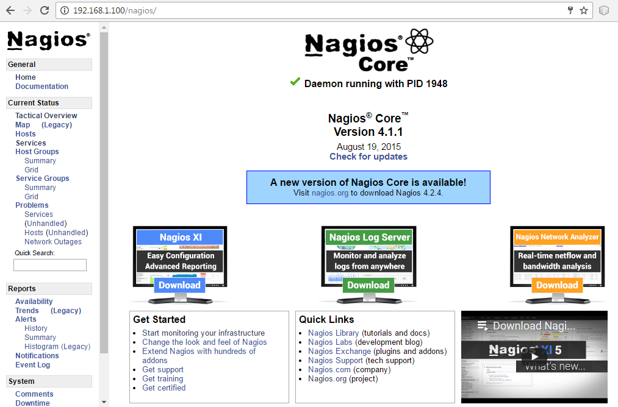

At the moment, Nagios is only monitoring itself, so we need to add a server for it to observe.

**Step 8: Add hosts to monitor**

Create a host file for the site you want to monitor (replace “myhost” with your host name):

$ sudo nano /usr/local/nagios/etc/servers/myhost.cfg

Add this text to the file, replacing the host_name, alias and address fields with the appropriate details.

sudo define host {  
 use linux-server  
 host_name The name of the host e.g. myhost  
 alias A short description  
 address The IP address of the host  
 max_check_attempts 5  
 check_period 24x7  
 notification_interval 30  
 notification_period 24x7  
}

The monitored hosts can be seen in the Hosts page on the web interface.

